|  |  |
| --- | --- |
|  | 199.jpgHANcoder STM32 Trouble Shooting Guide |
|  | BitsChipsRC30Target_HANtune.jpg |
| Version 0.4  9/28/2016 | Trouble Shooting Guide |
|  | A guide containing the solutions to previously encountered problems |

HANcoder STM32 Trouble Shooting Guide

Trouble Shooting Guide

Contents

[Versioning 2](#_Toc462841325)

[Introduction 3](#_Toc462841326)

[1 Problems during installation 4](#_Toc462841327)

[2 Problems in the model 4](#_Toc462841328)

[2.1 The project contains ‘Unresolved Link’-blocks 4](#_Toc462841329)

[3 Problems during the build procedure 4](#_Toc462841330)

[3.1 Gmake: \*\*\* [model.obj] Error 1 4](#_Toc462841331)

[3.2 Gmake: \*\*\* [<modelname>.obj] Error 1 5](#_Toc462841332)

[3.3 Gmake: \*\*\* [clean] Error 2 5](#_Toc462841333)

[Possible problem 1 6](#_Toc462841334)

[Possible problem 2 6](#_Toc462841335)

[3.4 Error building model: dialog out of screen boundaries 6](#_Toc462841336)

[Problem: 6](#_Toc462841337)

[4 Problems with flashing 7](#_Toc462841338)

[4.1 Error during flash procedure with MicroBoot ‘Could not clear memory..’ 7](#_Toc462841339)

[Problem 7](#_Toc462841340)

-

# Versioning

|  |  |  |  |  |
| --- | --- | --- | --- | --- |
| **Nr** | **Date** | **Person** | **Changes** | **Status** |
| 0.0.1 | 28-09-2016 | J. van Kolfschoten | First version | Concept |

# Introduction

In this document the solution to previously encountered problems can be found.

To get personal help and to keep this document up to date, please contact the Jason van Kolfschoten: [Jason.vanKolfschoten@han.nl](mailto:Jason.vanKolfschoten@han.nl), if you encounter a problem which is not documented here.

# Problems during installation

## USB driver installation with Zadig.exe fails

When the openblt.cfg file is in a path with a long name the installation can fail. Switch to Advanced mode in the Options menu of the program to check is the Openblt.cfg file can be opened.

# Problems in the model

## The project contains ‘Unresolved Link’-blocks

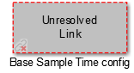

Possible causes & solutions

This probably means the paths haven’t been set correctly. Make sure the current folder of Matlab is the same folder as where the model file (.slx) is located. Close and reopen the model file once you have set the correct directory in Matlab, you should see the directory ‘blockset’.

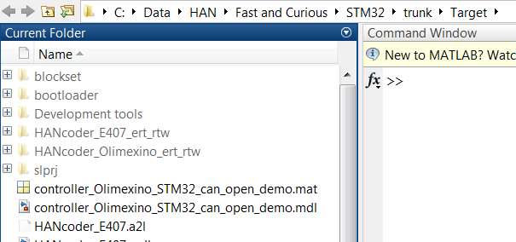.

Alternatively to reopening the model you can run the m-script librarySetup.m after redirecting Matlab to the correct directory.

# Problems during the build procedure

“### Real-Time Workshop build procedure for model: 'controller\_Olimexino\_STM32' aborted due to an error.”

There are a few possible errors with multiple causes during the build procedure

## Gmake: \*\*\* [model.obj] Error 1

After pressing the ‘Build model’ button or Ctrl+b the following error appears:

### Compiling model.c -o model.obj

arm-none-eabi-gcc: error: target\trunk\Target\controller\_Olimexino\_STM32\_ert\_rtw: No such file or directory

arm-none-eabi-gcc: error: target\trunk\Target: No such file or directory

gmake: \*\*\* [model.obj] Error 1

### Real-Time Workshop build procedure for model: 'controller\_Olimexino\_STM32' aborted due to an error.

>>

Possible problem:

There is a space in the folder where the model resides. Because of this the compiler cannot find the specified folder. See above: the compiler is directed to ‘target\trunk\Target\controller\_Olimexino\_STM32\_rtw’, this path is missing the ‘C:\...” The full path was: ‘C:\STM32 target\trunk\Target\controller\_Olimexino\_STM32\_rtw’.

## Gmake: \*\*\* [<modelname>.obj] Error 1

After pressing the ‘Build model’ button (Ctrl+b) the following error appears:

### Compiling controller\_Olimexino\_STM32.c -o controller\_Olimexino\_STM32.obj

In file included from controller\_Olimexino\_STM32.c:17:0:

controller\_Olimexino\_STM32.h:22:20: fatal error: timein.h: No such file or directory

#include "timein.h"

^

compilation terminated.

gmake: \*\*\* [controller\_Olimexino\_STM32.obj] Error 1

### Real-Time Workshop build procedure for model: 'controller\_Olimexino\_STM32' aborted due to an error.

Possible problem:

The ‘Simulation cache folder’ and ‘Code generation folder’ in the Simulink Preferences are not empty and not directing to the target folder

Solution:

Empty the fields ‘Simulation cache folder’ and ‘Code generation folder’ in Simulink Preferences.

## Gmake: \*\*\* [clean] Error 2

After pressing the ‘Build model’ button (Ctrl+b) the following error appears:

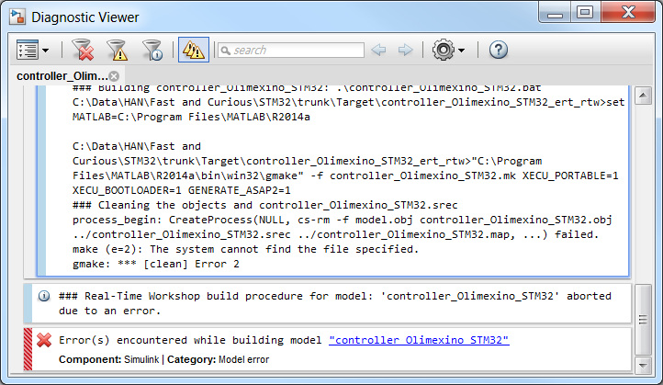

Possible problem 1: The PATH to the GNU ARM embedded toolchain is not set correctly in the environment variables.

Solution: Go to Environment Variables by right clicking ‘My Computer’ and selecting properties -> Click ‘Advanced system settings’ -> click ‘Environment Variables …’ Select the PATH variable and click edit to check/correct the folder location to:

‘C:\Program Files\GNU Tools ARM Embedded\5.4 2016q2\bin’.

Possible problem 2: MATLAB has not been run as administrator.

Solution: Run MATLAB as administrator

## Error building model: dialog out of screen boundaries

### Problem:

When starting the build procedure a dialog from HANcoder appears in the task bar but is not visible on the screen.

Solution: This is an Error that’s in MATLAB itself. There has to be a ‘startup m-file’ in the beginning file of MATLAB to prevent this from happening.  
Startup MATLAB, in the left section of the program, the **current folder** section, the file is shown which MATLAB starts with. Make a new script ( in the upper left corner ).

Copy paste the following script in the m-file and call this file **startup**

figure('units','pixels','position',[680 678 560 420]);

close all;

set(0,'defaultfigureposition',[680 678 560 420]);

clc

From now on, MATLAB will execute this script first when it is started. The dialog will appear in the screen from now on.

# Problems with flashing

## Error during flash procedure with MicroBoot ‘Could not clear memory..’

When trying to flash the STM32 Olimexino via CAN or USB the following error appears:

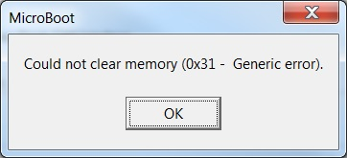

Problem: The model was not set up for use with the bootloader via CAN

Solution: Set ‘HANcoder\_BOOTLOADER=1’ at the make command in the configuration parameters of the model. See below..

